**gspca cupcake week**

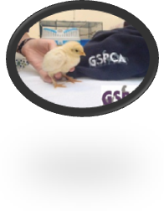

**27th April – 3rd may 2015**

**Raising funds to help animals in guernsey**



**Date __________**



**time ___________**

**Location __________ ___________________**



**contact ___________**

**phone _____________**



**To find out more and get a cupcake week pack pop into the shelter, ring 01481 257261 or go to**

**www.gspca.org.gg/page/gspca-cupcake-week**