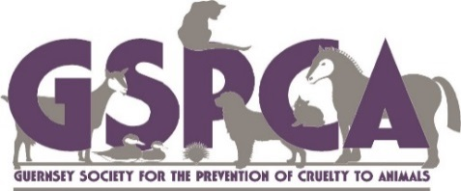 & 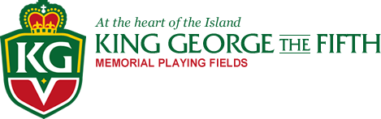
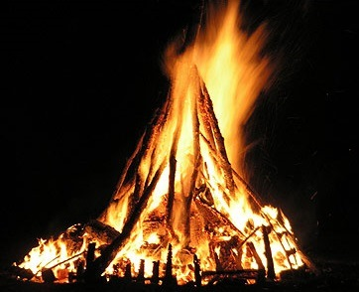Dog Friendly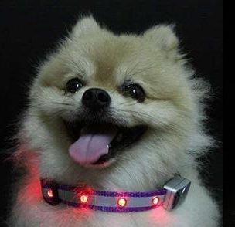
Bonfire Family Fun Evening
**THERE WILL BE NO FIREWORKS AT THIS EVENT**
To catch the bus that passes the KGV please check route 41 for more www.buses.gg
Thursday 13th November - Starts 6.00pm
At the KGV including a Dog Night Safety Wear Fun Fashion Show at 6.45pm & School Poster Competition winner announced at 7.15pm
Dog Night Safety Fashion Show minimum donation £3 (Every dog wins a prize)
(Limited parking please book early)
Pre Booked Family (max 5 persons) Car - £7.50 (Dogs FREE)
Pre Booked Family on Foot (max 5 persons) - £5.00 (Dogs FREE)
Adult (on the night) - £2.00 (Dogs FREE) Child (on the night) - £1.00
(If you are planning on bringing a car please pre-book we have very limited parking. Parking on the night (if available) will be charged at £5.00 per car plus above fee per person)
To Book please call 01481 257261 & for cars please quote your vehicle registration and family name or online www.gspca.org.gg
There will be raffles, games, tombolas, pet goods, glow sticks & much more for the family
BBQ & Bar (Vegetarian and Gluten free options available)
We are appealing for all to please avoid arranging a firework display on Thursday 13th November 2014
The winner of the Firework Safety Awareness School Poster Competition will win a party for their school year group which will include an hours entertainment on the 3G before being fed by the team at the KGV

