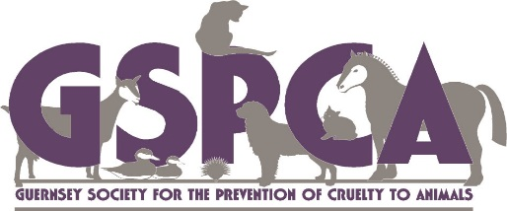
Scottish Themed St Andrews
Family Fun Day
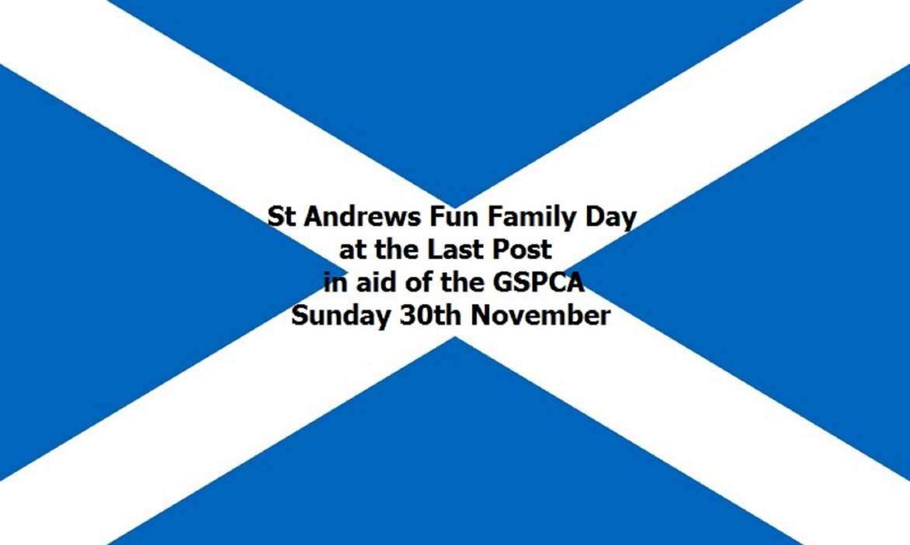
at the Last Post, St Andrews
Sunday 30th November 2014 12pm until late
Free Entry but donations welcomed
GU10, Bagpiper, Fun Games, Stalls, Tombolas, Christmas & Pet Goods, Face Painting, Scottish Fancy Dress Competition, Fun Dog Show, Hog Roast, BBQ & much more …….
For details call 01481 257261 or go to www.gspca.org.gg

