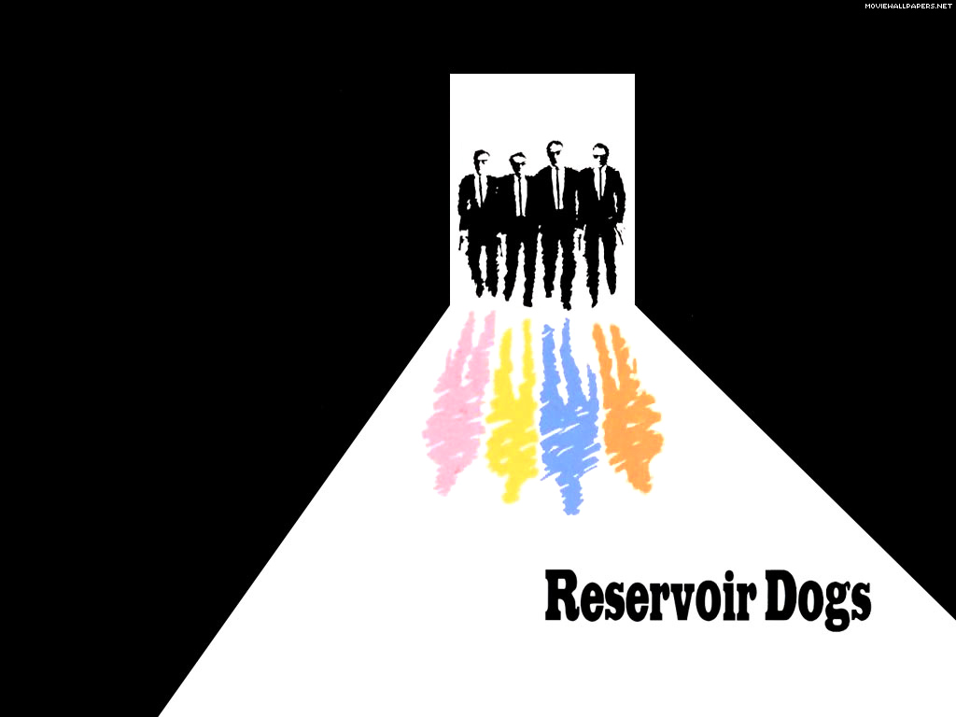

Sponsored Walk

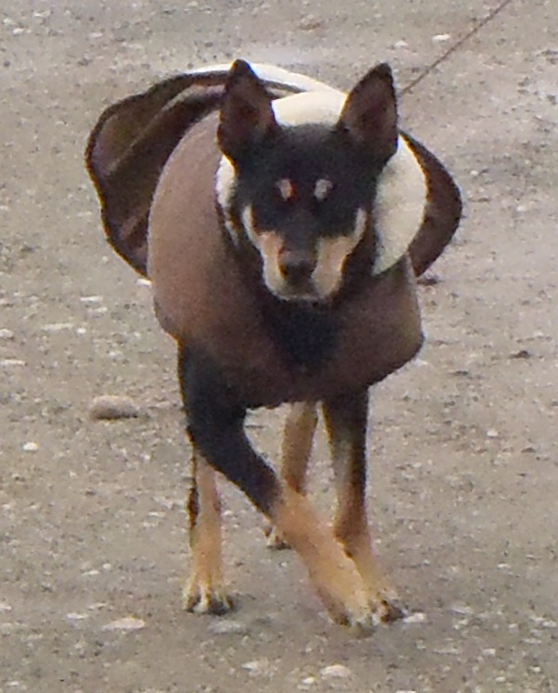
Produced by Sidney’s Sponsored Events
Directed by Steve Byrne
Sunday 22nd September 2013 at 10.00am
Meeting in Reservoir Rue des Annevilles Car Park
Finishing in Reservoir Rue a L’Or Car Park
Certificates for all Walkers & Their Dogs
Sponsorship forms can be downloaded from GSPCA website or collected from the GSPCA reception.
www.gspca.org.gg

