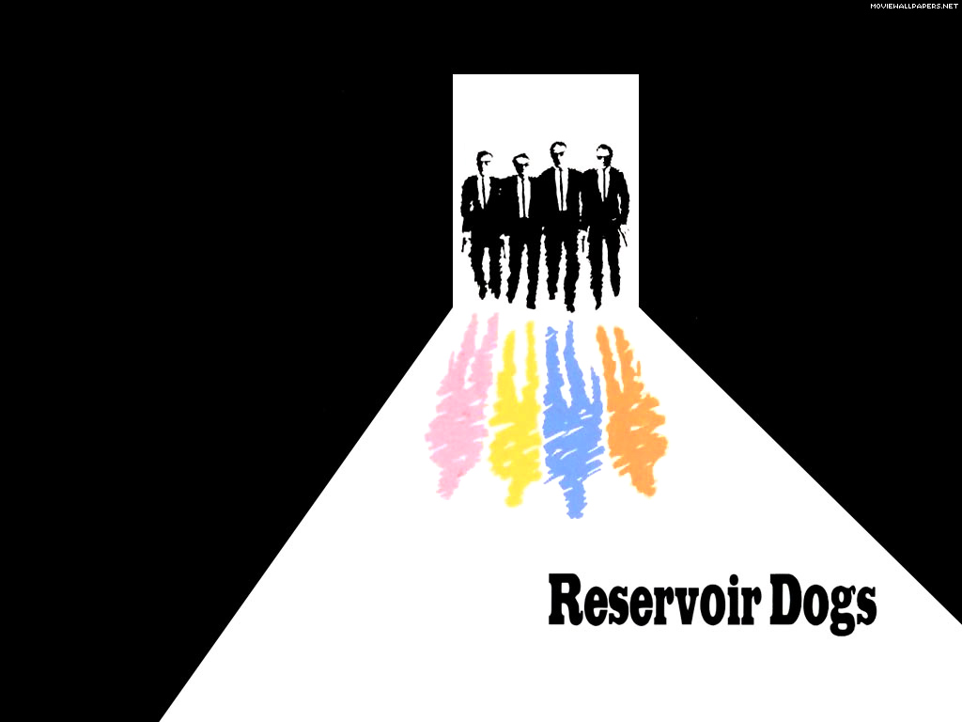 Sponsored Walk
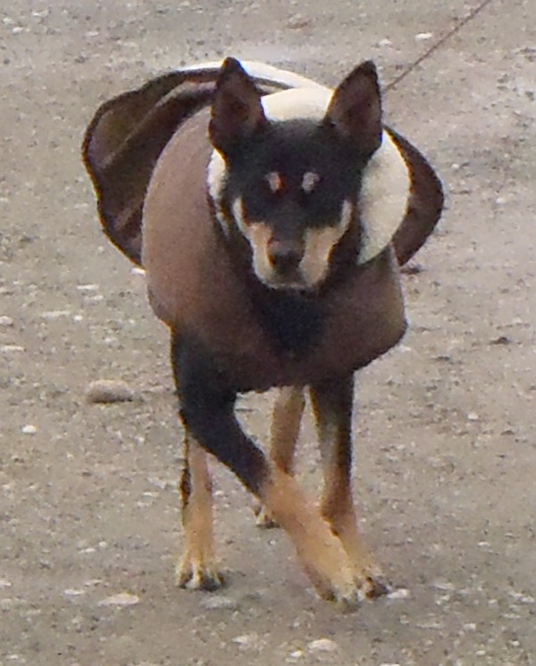
Produced by Sidney’s Sponsored Events
Directed by Steve Byrne
Sunday 22nd September 2013 at 10.00am
Meeting in Reservoir Rue Des Annevilles Car Park. Finishing in Reservoir Rue A L’OR Car Park
Please sponsor _____________________________ for the Reservoir Dog Sponsored Walk in aid of the GSPCA on the 22nd September from 10am.
For More Details please contact Steve Byrne, GSPCA Manager – stevejbyrne@gspca.org.gg or call 01481 257261
Name | Contact details | Donation | Paid
Name | Contact details | Donation | Paid
Name | Contact details | Donation | Paid

